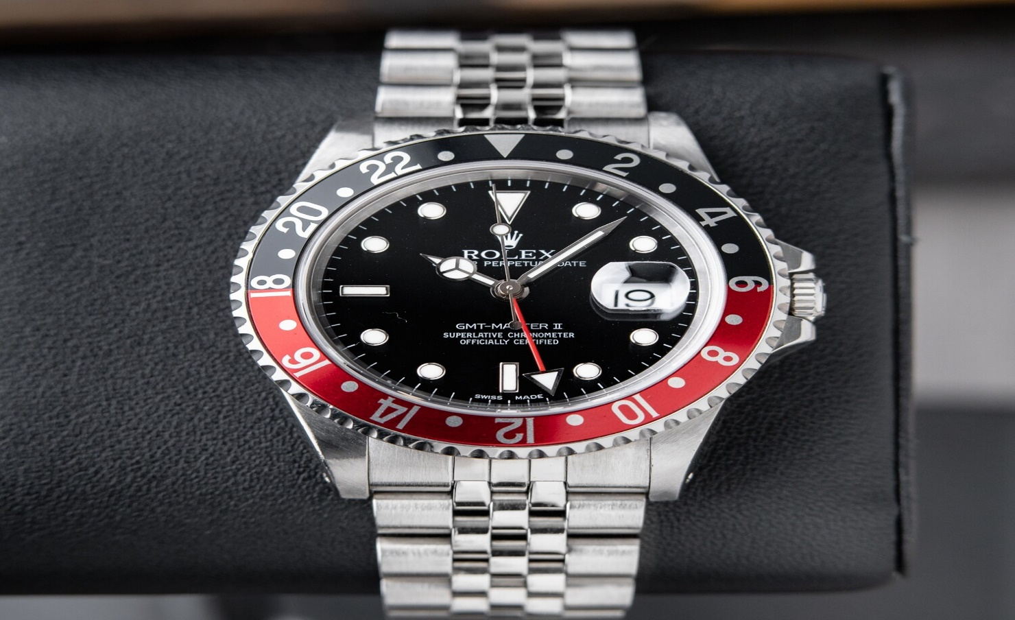ROLEX

DESCRIPTION: Rolex is a world-renowned luxury watch brand known for its exceptional craftsmanship, precision, and timeless design. Founded in 1905, Rolex has set the standard for high-end timepieces, combining innovation with tradition. Each Rolex watch is crafted from the finest materials and undergoes rigorous testing to ensure durability and performance. From iconic models like the Submariner and Daytona to the elegant Date-just and Day-Date, Rolex offers a diverse range of watches suited for every occasion. Synonymous with prestige and excellence, owning a Rolex is not just about telling time—it’s a statement of success and sophistication.